MICE
MICE as a short form for Meetings, Incentives, Conferences and Exhibitions represents a niche market that all trade travellers are seeking for. The ideal MICE destination is one that has modern facilities for holding these events and offers MICE tourists the opportunity of enjoying an extended holiday. Kenya with its best hotels, nice food, and beautiful beaches is an ideal destination for all events offering both, the best modern and more developed facilities in addition to endless holiday packages to ensure your event is an absolute success.
At Seven By Far Tours Kenya we take care of everything revolves around your event, visions and requirements, this is the Key of our success. We provide truly and complete customer care in all project phases i.e. planning, consultation, organization and realization. Our expertise in coordinating complex processes, our ability to listen, understand and continuously develop new ideas is essential to make your dream tangible.
Seven By Far Tours Kenya strong and perfect relations with the government and all hotels in addition to our various well equipped venues, well skilled and experienced staff will ensure our capability, deep knowledge, and success that suite any event.
As the regions market leader, we take great pride in our creative approach and careful attention to detail, our MICE-specialists have over two decades of international experience combined with high skills to bring new objectives and features to your MICE programme. Moreover our large volume of business gives us the opportunity to give the lowest rates to fit your specific budget and matches or exceeds your expectations.
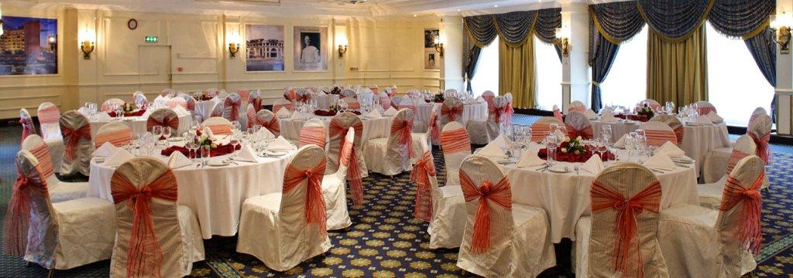

Meetings & Events
Our deep knowledge in devising, preparing and implementing combined with our well trained staff will ensure you our capability and success in meetings and events arrangements of all sizes.

Incentives
Seven By Far Tours Kenya offers an original and high quality group travel. Incentive Tours to Kenya, Tanzania& Uganda are rewards by employers for your hard work and dedication. You deserve a holiday to relax and recharge yourself before you get back to work again. Obviously rewards for employees will maintain their motivation, hard work and will make them more satisfied and loyal. Incentive tours to Kenya are sure to make you want another incentive holiday very soon.

Conferences
Conferences are not just about the exchange of information or the amount and length of lectures held. Emotional factors are becoming the centre of attention. Workshops, discussions, panels and business theatres, are forms of communication that will motivate the participants to think about the offered topics. Infotainment events have a substantially higher potential for participants identifying themselves with them, than traditional information conferences.
Creative meetings, extraordinary seminars, international conferences makes a great difference, our team will assist you throughout the transaction and implementation processes.

Exhibitions
At Seven By Far Tours Kenya we come to introduce East Africa as the world's leading commercial destination. We organize international events and manage high-tech settings, we develop energetic commercial environments and provide high value-added services to create a unique and an exclusive customer experiences.
Regardless of size and complexity Seven By Far Tours Kenya will choose for you a desirable location with flexible and resourceful exhibition spaces, and impressive facilities that will build in success to your event.
Our extremely professional team who are dedicated to technology and advanced facilities will ensure you a service quality that will make your event a memorable experience.
